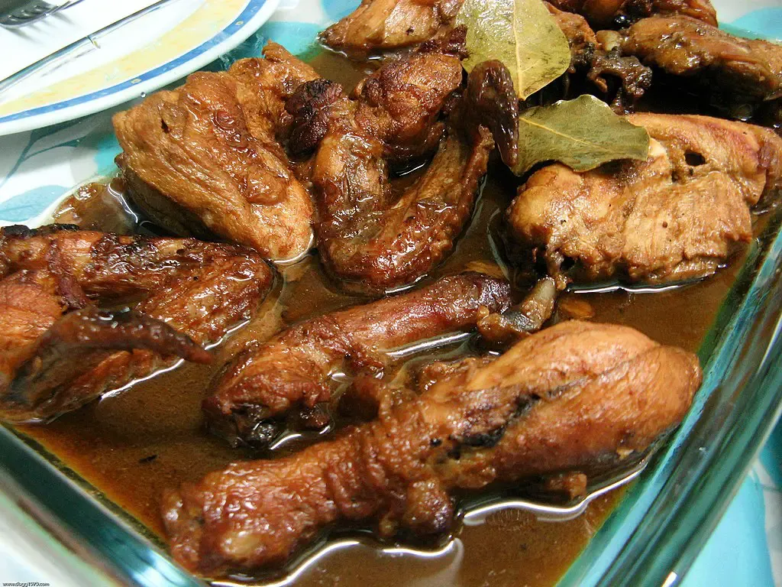

**Chicken Adobo - ₱1,200**

A classic Filipino comfort food, featuring tender chicken pieces braised in a rich, savory sauce of soy sauce and vinegar. This dish is aromatic and full of bold, complex flavors that are a true taste of home.

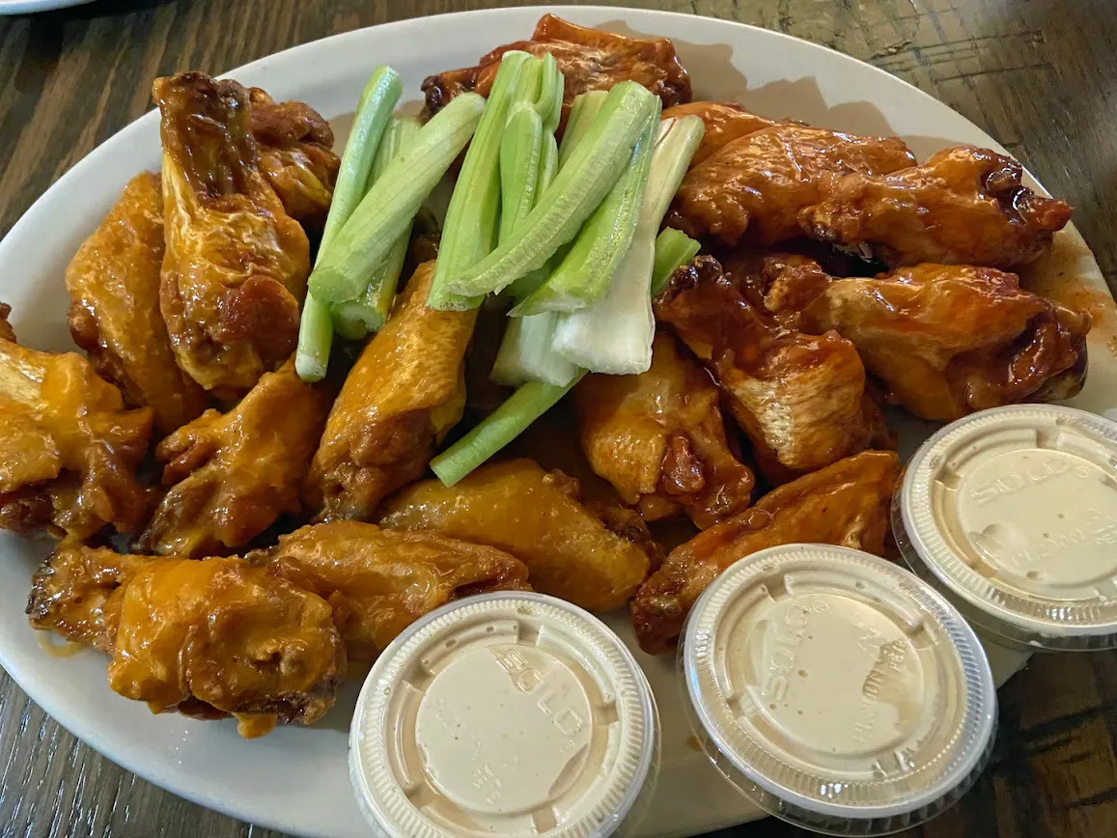

**Fried Chicken - ₱1,399**

A platter of crispy, bite-sized chicken pieces, topped with vibrant green onions, served with a side of dipping sauce. This dish is a perfect mix of crunchy texture and savory flavor.

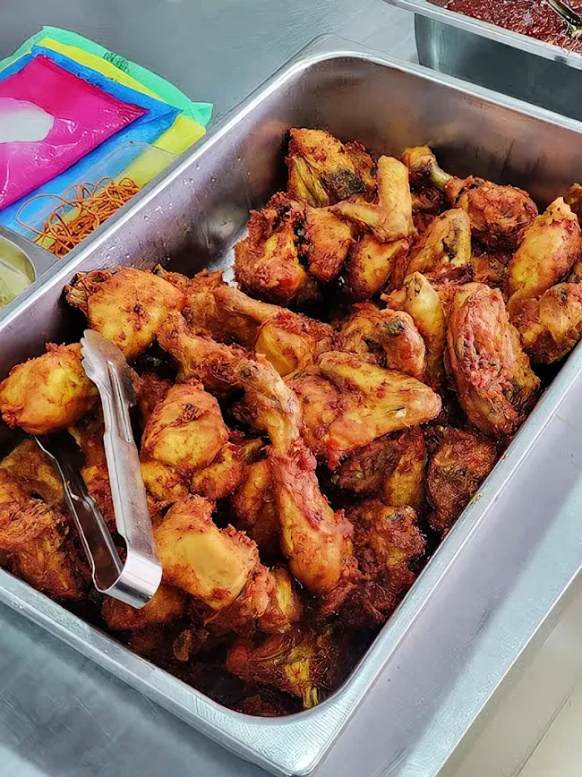

**Fried Chicken Wings Tray** – **₱1,300**

(Variety pack with spicy and golden-brown wings, great for parties and mixed cravings.)

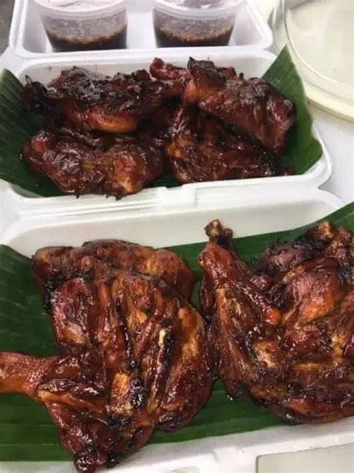

**Chicken Inasal Tray** – **₱1,400**

(Smoky, tangy grilled chicken pieces. Ideal for gatherings with grilled favorites.)

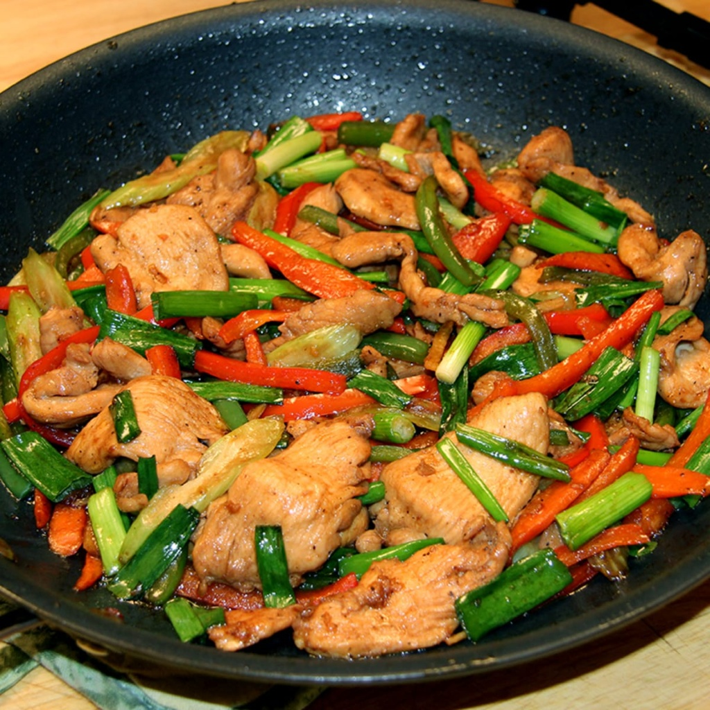

**Chicken Stir-fry- ₱1,299**

(A stir-fried dish with chicken strips, vegetables, and sometimes rice noodles, perfect for a filling meal.)

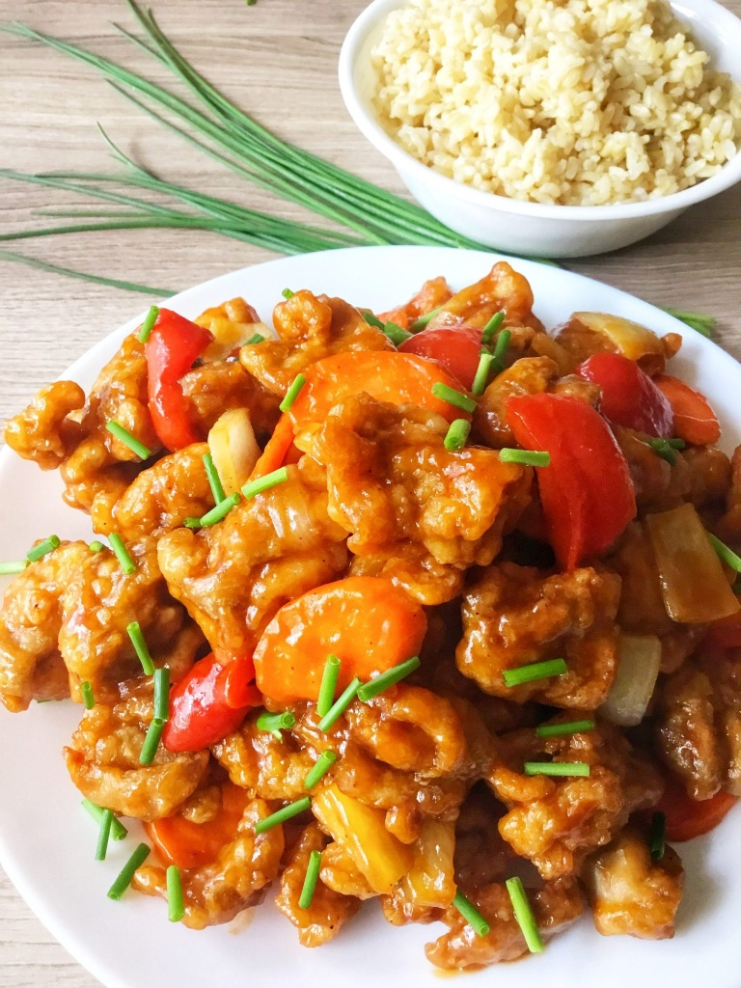

**Sweet and Sour Chicken** **- ₱1,360**

(A popular dish with crispy, breaded chicken pieces tossed in a bright orange sweet and sour sauce with bell peppers. This dish is perfect for those who enjoy a mix of sweet and tangy flavors.)

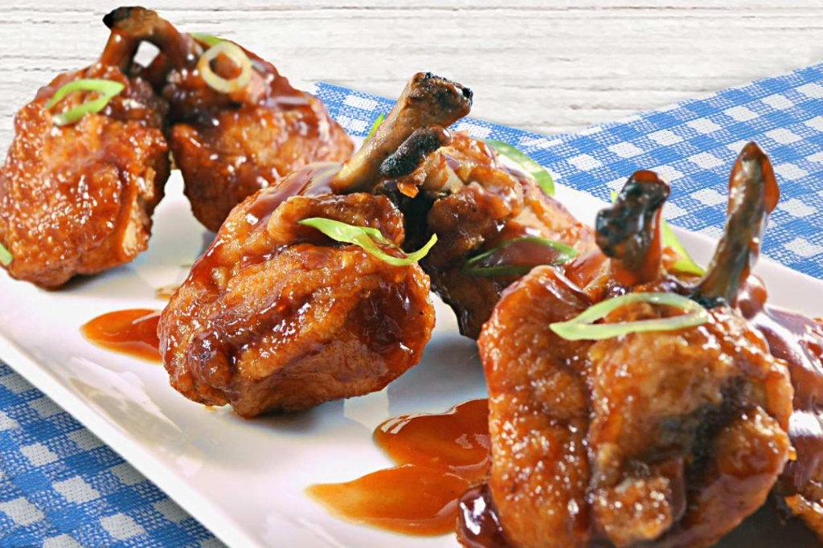

**Honey Garlic Chicken - ₱1,480**

(A savory-sweet delight, these chicken wings are glazed in a sticky, rich honey-garlic sauce and topped with fresh green onions. They're a perfect crowd-pleaser for any event.)

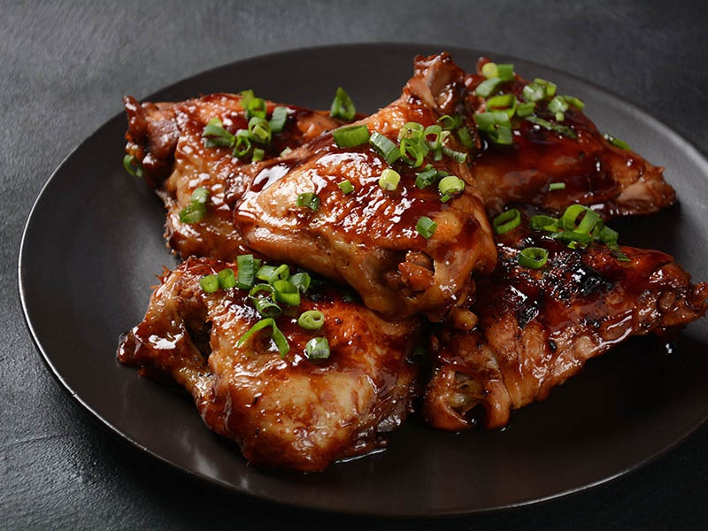

**Honey Bbq Chicken - ₱1,799**

(A savory-sweet delight, these chicken wings are glazed in a sticky, rich honey-bbq sauce and topped with fresh green onions. They're a perfect crowd-pleaser for any event.)

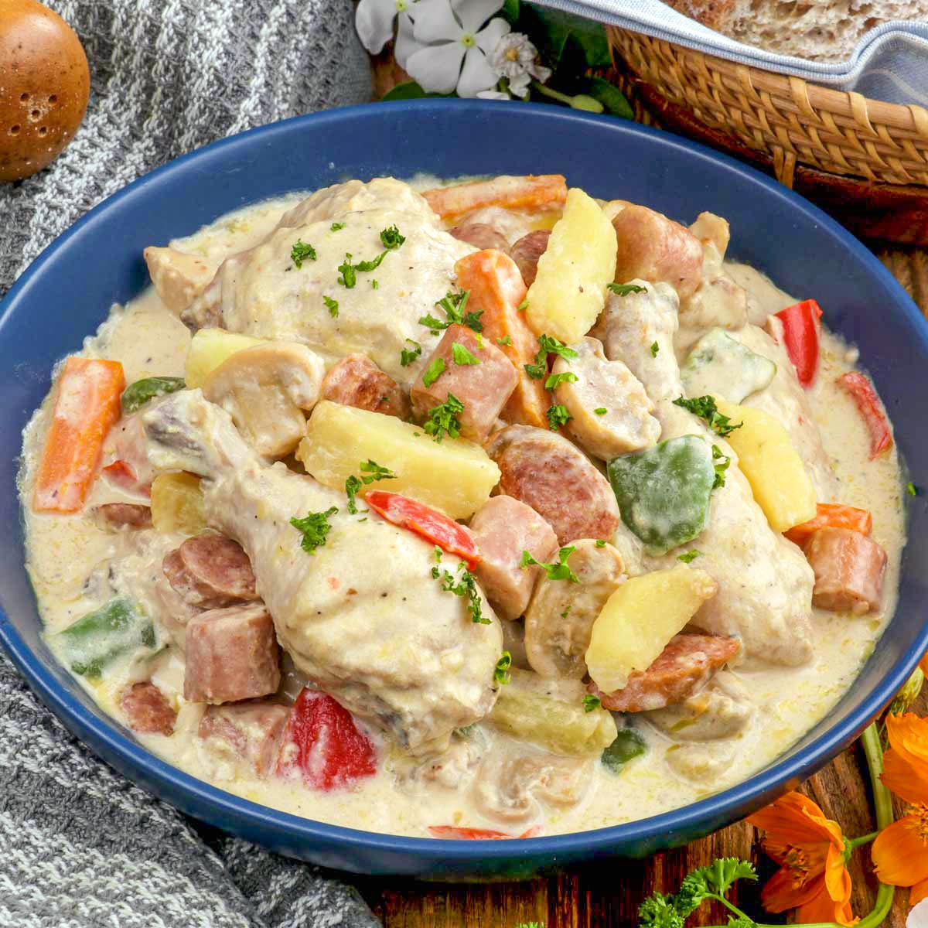

**Chicken Bicol Express - ₱1,499**

(A rich and creamy Filipino stew, this dish features tender chicken chunks simmered in **coconut milk** and spiced with an abundance of **green chilies** and red bell peppers. It is a hearty and flavorful dish inspired by the spicy cuisine of the Bicol region.)

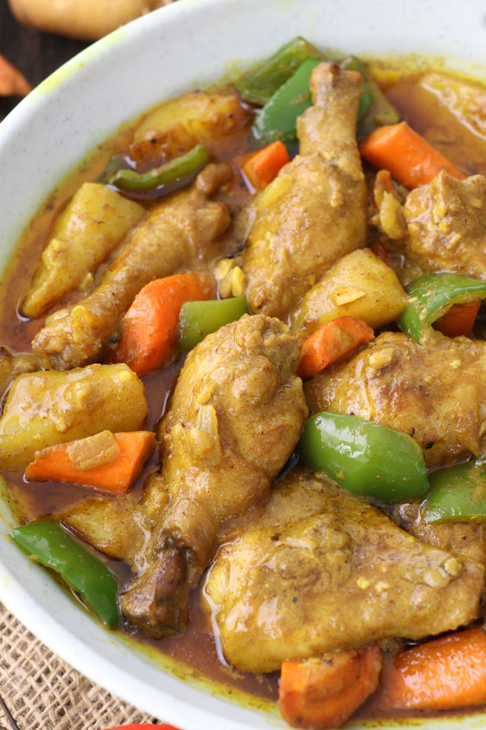

**Chicken Curry- ₱1,399**

(A creamy and mildly spicy chicken stew with potatoes and carrots simmered in a rich curry sauce. It's a comforting and aromatic dish perfect for sharing.)

**Beef**

**Fish  
Pork**

**Seafood**

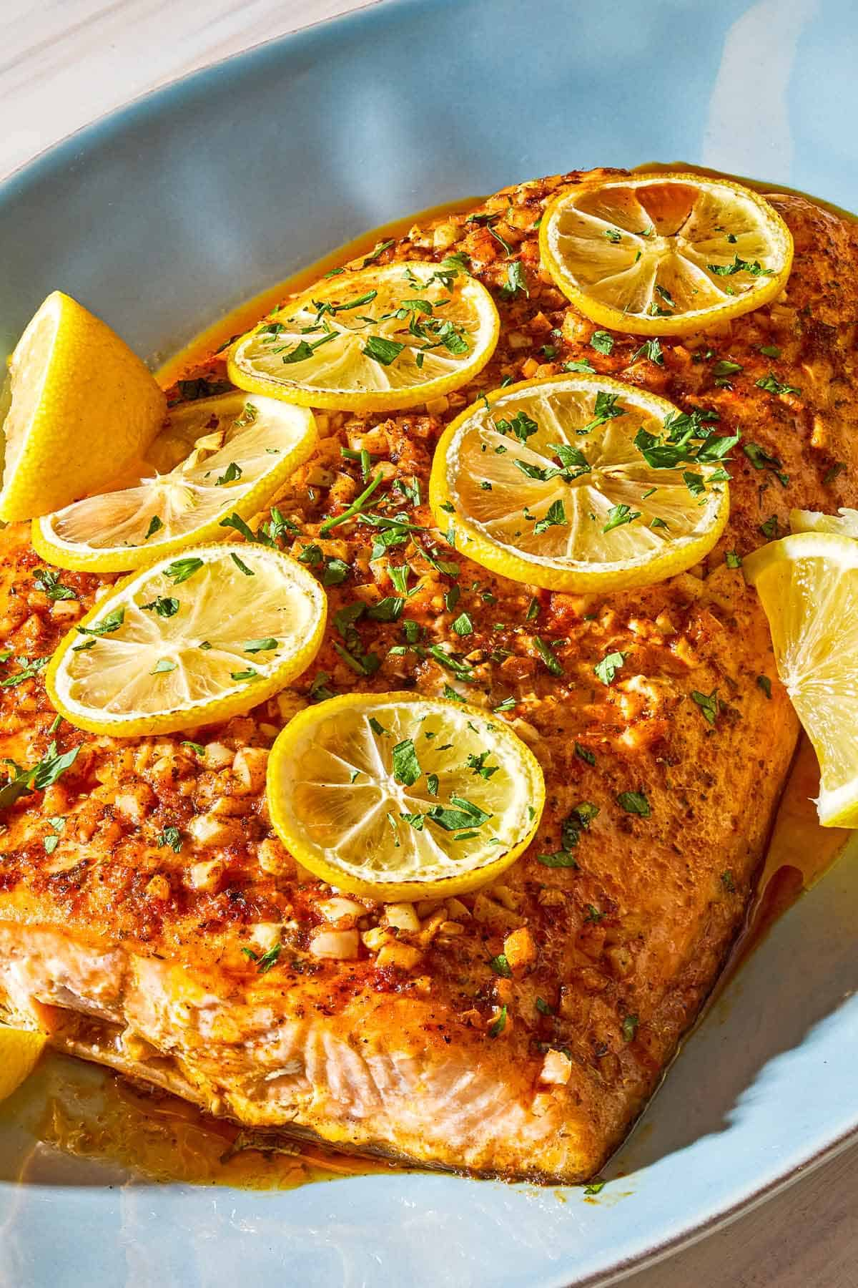

1. **Lemon Garlic Butter Salmon - ₱1899**

Lemon Garlic Butter Salmon is a delightful seafood dish featuring a perfectly seared salmon fillet bathed in a luscious lemon-garlic butter sauce. Each bite offers a burst of zesty freshness balanced with rich, creamy undertones. Served hot and tender, this dish melts in your mouth and pairs wonderfully with rice or mashed potatoes for a satisfying meal.

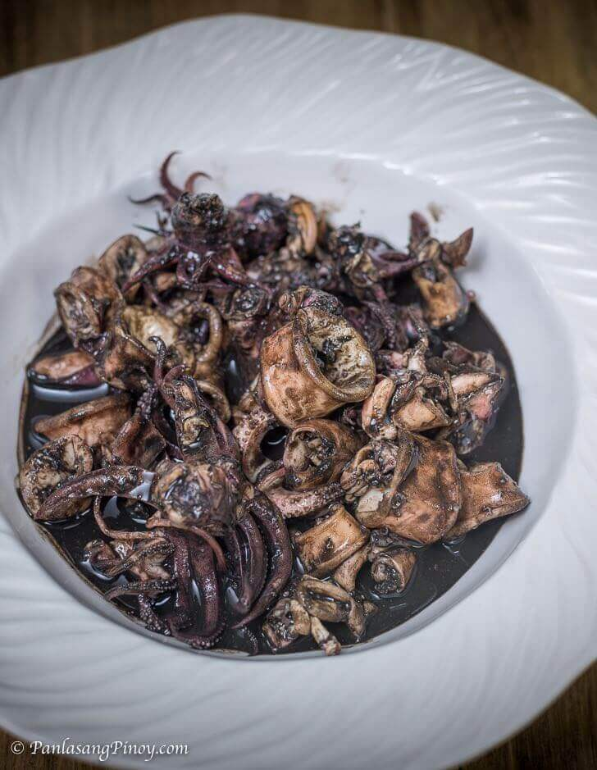

1. **Adobong Pusit - ₱1450**Adobong Pusit is a tasty squid dish cooked using the popular Filipino adobo method. Squid is first boiled in soy sauce and vinegar then later sautéed in garlic, onions and tomatoes; this brings in an awesome array of flavors that will surely activate your taste buds.

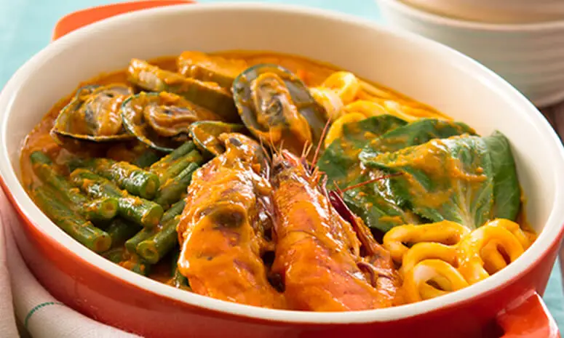

1. **Seafood Kare Kare - ₱1799**

Seafood Kare-Kare brings a coastal twist to the traditional Filipino peanut stew. This version features a medley of shrimp, squid, and mussels cooked in a creamy peanut sauce, served with blanched vegetables like eggplant, string beans, and banana blossoms. Accompanied by bagoong (shrimp paste), this dish delivers a perfect harmony of savory, nutty, and umami-rich flavors.

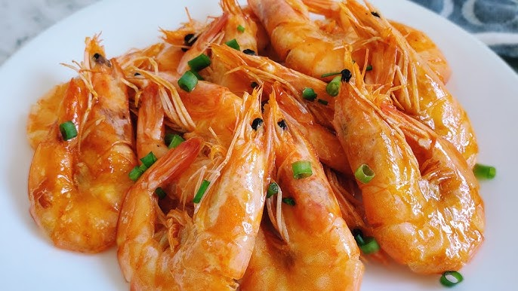

1. **Halabos na Hipon with Butter - ₱1699**

Halabos na Hipon with Butter is a simple yet irresistible Filipino favorite. Fresh shrimp are sautéed in rich butter and aromatic garlic, enhancing their natural sweetness and tenderness. The buttery sauce coats each piece beautifully, creating a comforting dish that’s best paired with warm rice or enjoyed as a flavorful pulutan.

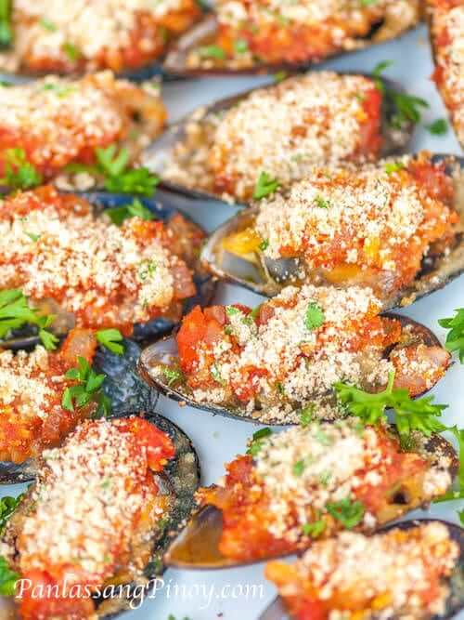

1. **Grilled Mussels - ₱1200**

Grilled Mussels are a smoky, savory delight straight from the grill. Fresh mussels are topped with a garlic butter mixture, then grilled until the shells open and the edges turn slightly crisp. The result is a mouthwatering combination of smoky, garlicky, and ocean-fresh flavors — perfect as an appetizer or main dish.

**Vegetables**

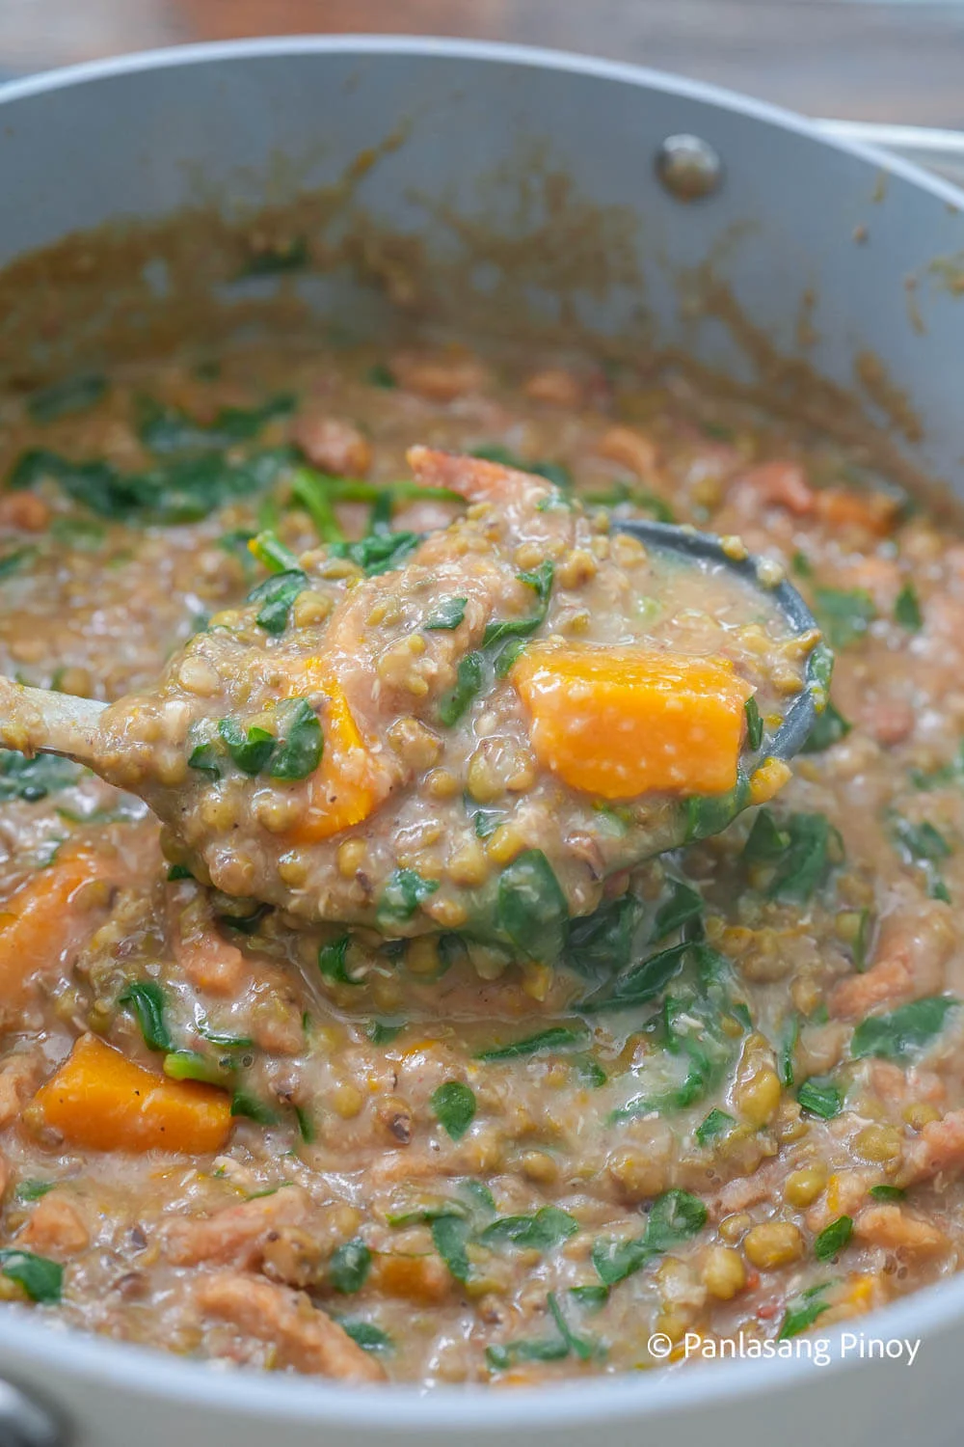

**Ginisang Monggo with Kalabasa – ₱ 850**

Ginisang Monggo with Kalabasa is a mung bean stew that’s common in Filipino households. The base starts with sautéed garlic, onions, and tomatoes. Munggo is simmered until soft and creamy, then joined by calabaza squash, leafy greens like malunggay or spinach, and seasoned with fish sauce and Magic Sarap. Topped with crispy pork rinds, it is a hearty and simple kind of dish that’s just as good with fried pork as it is on its own.

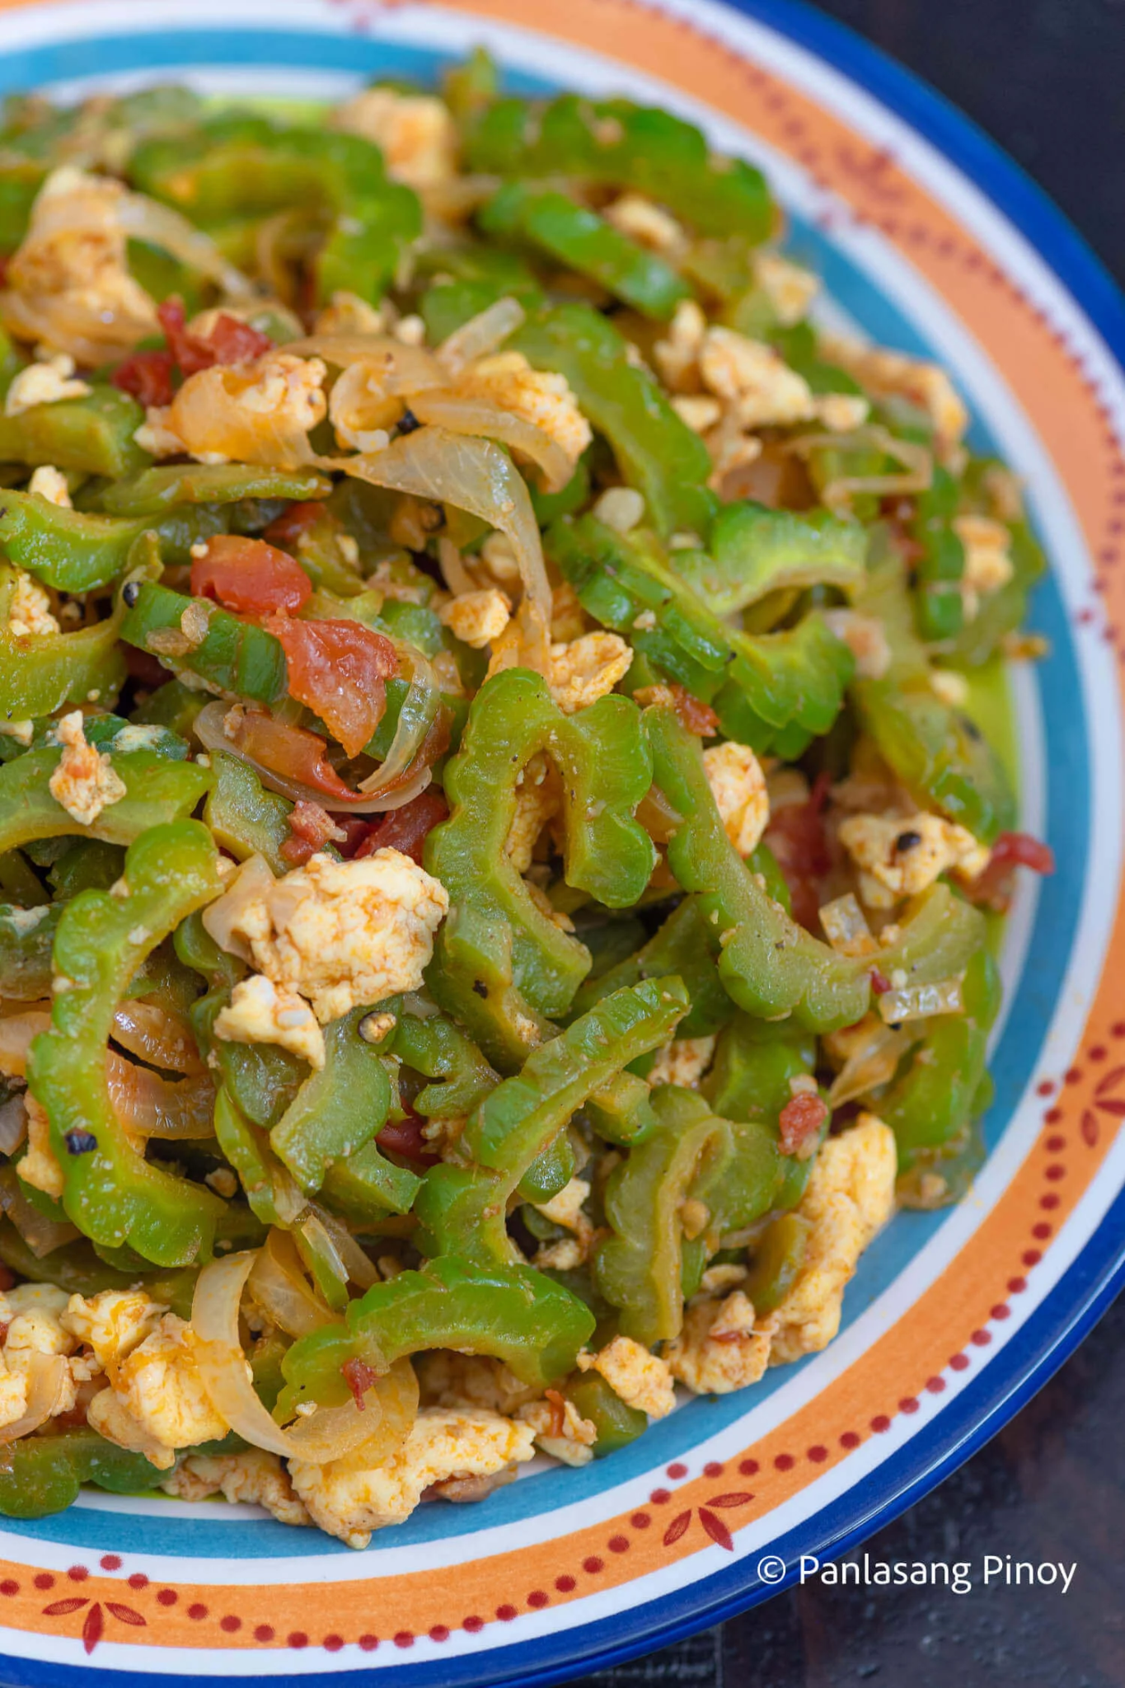

**Ginisang Ampalaya - ₱720**

Ginisang Ampalaya is a classic Filipino dish made of sautéed bitter melon (ampalaya) with eggs, garlic, onions, and tomatoes. It’s known for its distinct bitter flavor, which balances well with the savory and slightly sweet taste of the other ingredients. Nutritious and simple to prepare, it’s often served as a healthy everyday meal with rice.

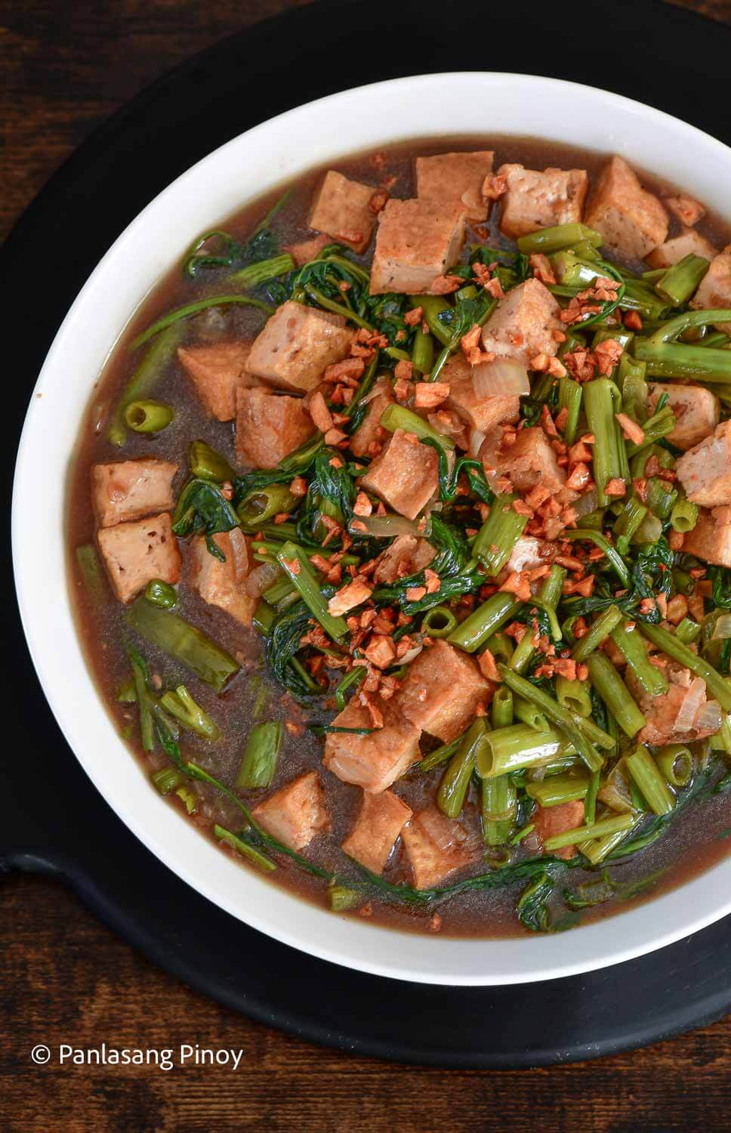

**Garlic Tokwa and Kangkong in Oyster Sauce - ₱910**

Kangkong and Ground Pork with Oyster Sauce Stir-Fry is a flavorful Filipino dish made by sautéing ground pork with garlic, onions, and kangkong (water spinach), then seasoning it with oyster sauce for a savory, slightly sweet taste. It’s a quick and nutritious meal that pairs perfectly with steamed rice.

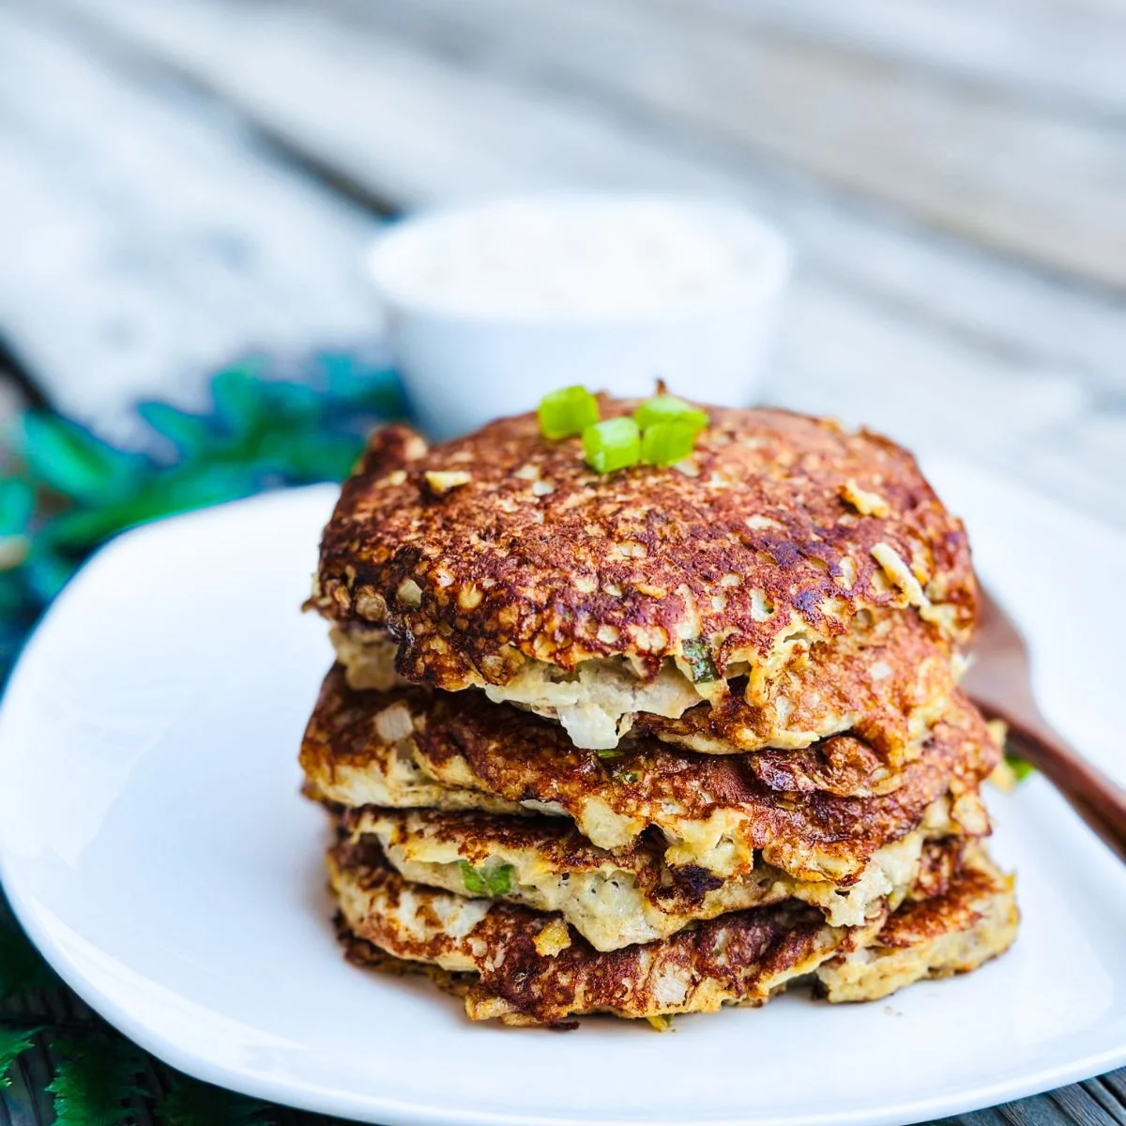

**Tortang Talong - ₱790**

Ginisang Ampalaya is a classic Filipino dish made of sautéed bitter melon (ampalaya) with eggs, garlic, onions, and tomatoes. It’s known for its distinct bitter flavor, which balances well with the savory and slightly sweet taste of the other ingredients. Nutritious and simple to prepare, it’s often served as a healthy everyday meal with rice.

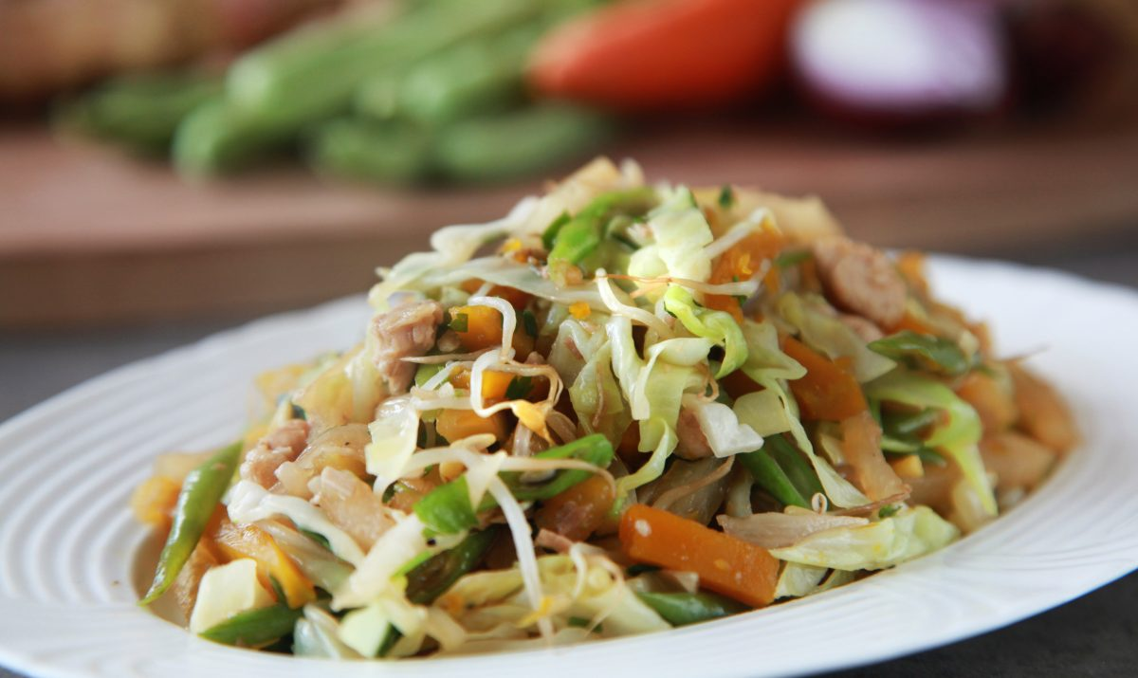

**Lumpiang Hubad - ₱835**

Lumpiang Hubad is a Filipino vegetable dish that means “naked spring roll,” featuring the same fresh, sautéed vegetable filling as lumpiang sariwa but served without the wrapper. It’s typically made with mixed vegetables like carrots, green beans, and cabbage, topped with crushed peanuts and a sweet-savory garlic sauce.

**Dessert**

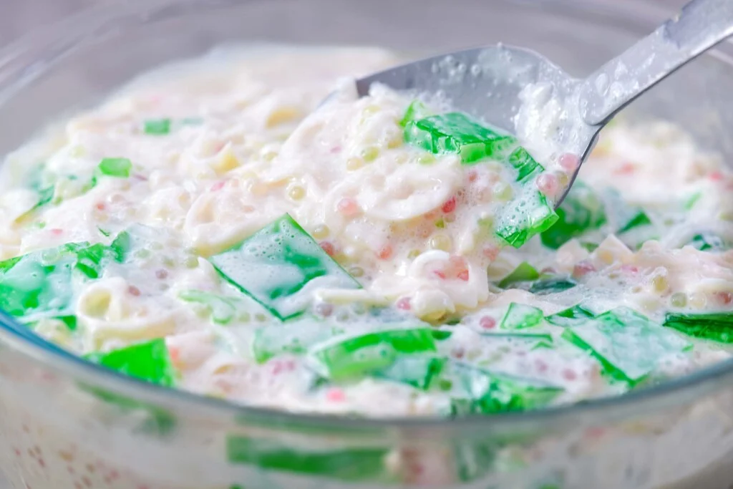

1. **Buko Pandan – ₱850**

Buko Pandan is a refreshing Filipino dessert made with tender young coconut strips and chewy pandan-flavored jelly mixed in creamy sweetened milk. This classic treat offers a perfect balance of tropical aroma and smooth, velvety texture — a cool and delightful way to end any meal.

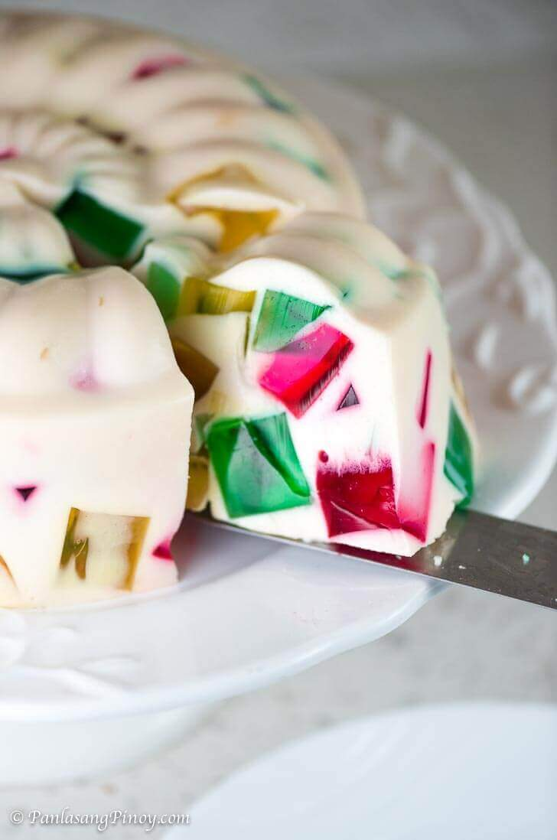

1. **Cathedral Window Gelatin – ₱950**

Cathedral Window Gelatin is a festive dessert that captivates both the eyes and taste buds. Colorful cubes of jelly are suspended in a rich, creamy gelatin base, resembling the stained-glass windows of a cathedral. Its smooth, milky sweetness and vibrant presentation make it a favorite for celebrations.

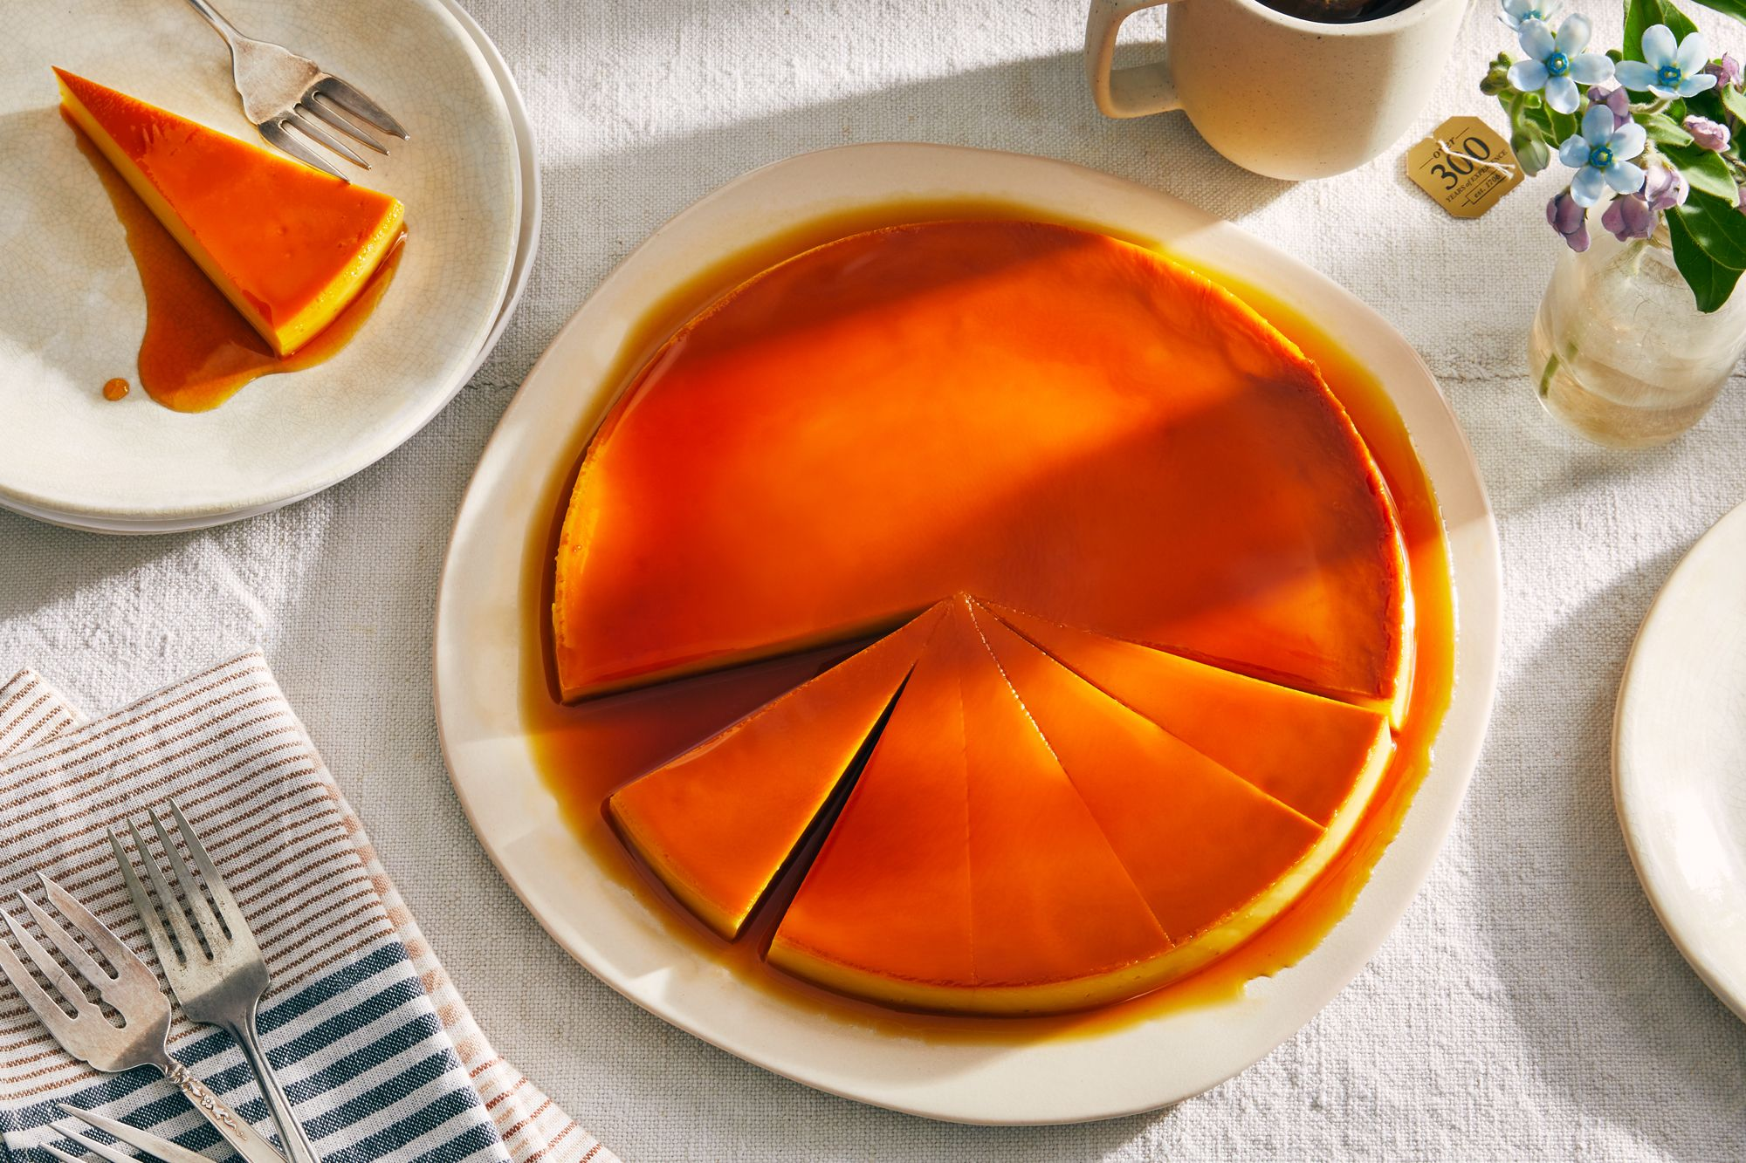

1. **Leche Flan – ₱750**

Leche Flan is a timeless Filipino custard dessert known for its silky texture and rich caramel flavor. Made from egg yolks, milk, and sugar, it’s steamed to perfection and topped with a glossy caramel syrup that melts in your mouth. This classic sweet treat is smooth, creamy, and irresistibly indulgent.

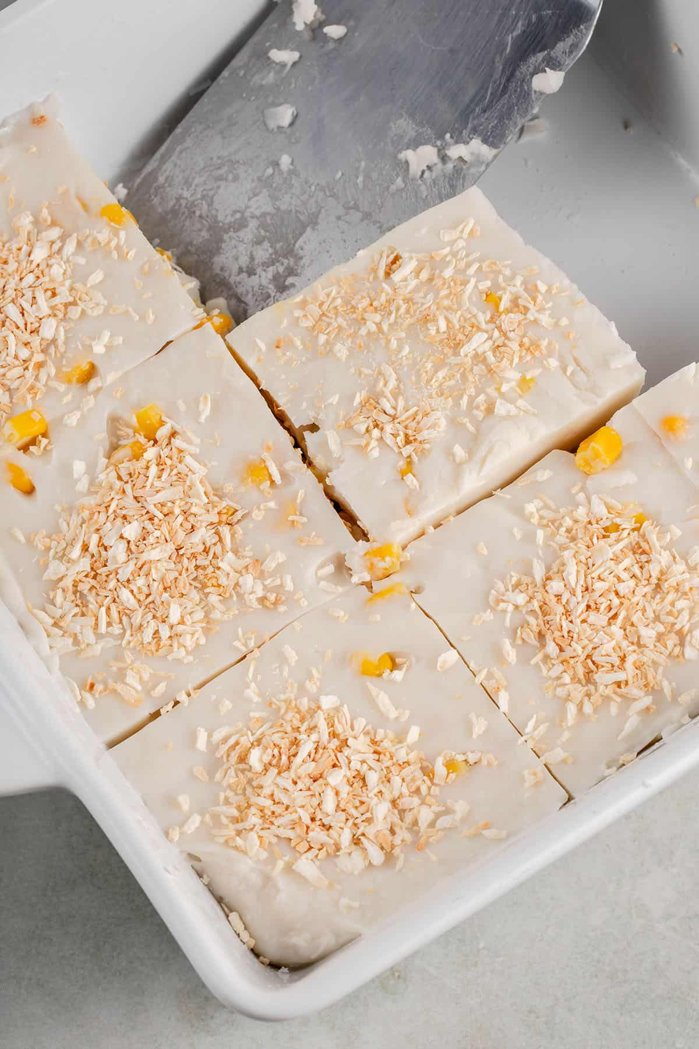

1. **Maja Blanca – ₱700**

Maja Blanca is a creamy coconut pudding made from coconut milk, cornstarch, and sugar, topped with toasted latik or corn kernels. Known as the Filipino version of coconut milk pudding, it’s soft, light, and delicately sweet — a comforting dessert that’s both traditional and satisfying.

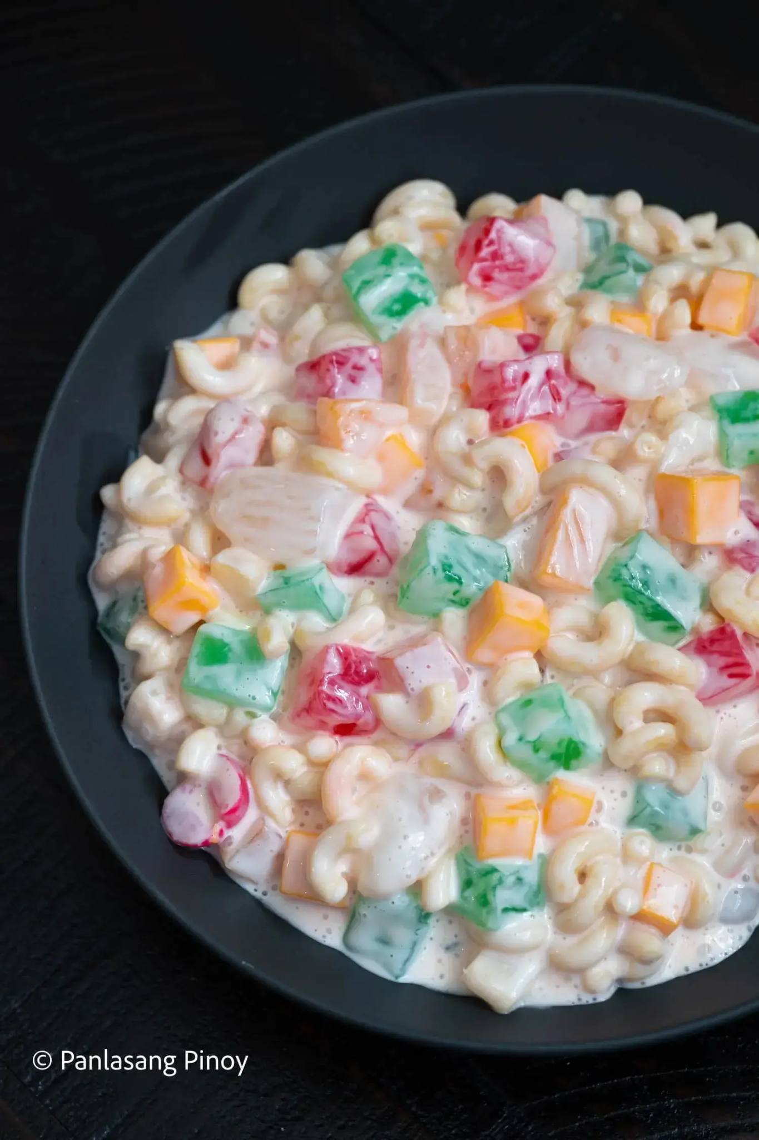

1. **Macaroni Fruit Salad – ₱800**

Macaroni Fruit Salad is a uniquely Filipino twist on the classic fruit salad, made with cooked macaroni, mixed fruits, and a rich, creamy dressing of sweetened cream and condensed milk. It’s a festive, colorful dessert that’s both sweet and tangy — a holiday favorite loved by kids and adults alike.